Name - SIDDHANT DHAMDHERE
Div – ENTC B
Roll no – 49

<!DOCTYPE html>
<html>
<head>
<meta charset="UTF-8">
<title>My Website Home Page</title>
<script>
function changeColorOnHover() {
document.body.bgColor = "lightgreen";
}

function resetColor() {
document.body.bgColor = "white";
}

function changeColorOnFocus() {
document.body.bgColor = "lightyellow";
}
</script>
</head>
<body bgcolor="white">
<h1>Welcome to My Website</h1>
<p>Hover over the button or click inside the input box to change background color.</p>

<input type="text" placeholder="Click here..." onfocus="changeColorOnFocus()" onblur="resetColor()">
<br><br>
<button onmouseover="changeColorOnHover()" onmouseout="resetColor()">Hover Over Me</button>
</body>
</html>

On Mouse Event:

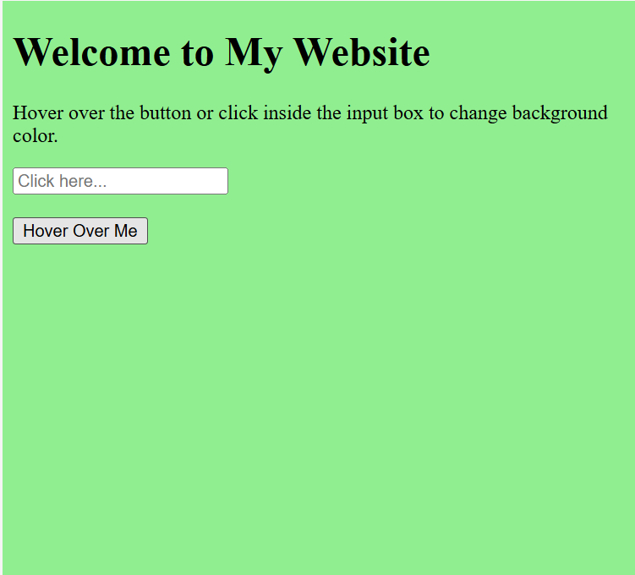

On Focus Event:

